Indian Banking Transaction Analysis
(2019 – 2025)

Project Overview
This project analyses Indian banking transaction data using Power BI to identify customer transaction behavior, banking trends, account performance, and financial insights. The goal is to enable data-driven decision-making for banking operations and customer relationship management.
Project Objectives
1. Analyse Banking Transaction Performance
To evaluate overall transaction trends, transaction growth, and customer transaction activity across different banking services.
2. Monitor Customer Financial Activity
To track customer account balances, transaction behavior, and banking engagement in real time.
3. Identify High-Value Customers
To highlight customers with high transaction amounts and strong banking activity for better customer targeting.
4. Understand Transaction & Account Patterns
To analyse customer transaction preferences, account usage, and transaction direction patterns.
5. Improve Financial Monitoring
To detect unusual transaction activity and improve banking operational efficiency through data insights.
6. Track Key Banking KPIs
To calculate and visualize KPIs such as Total Transactions, Total Transaction Amount, Average Transaction Value, Customer Count, and Account Balance.
7. Enable Data-Driven Decision Making
To provide stakeholders with interactive dashboards for quick and informed financial and business decisions.
8. Enhance Customer Analysis
To analyse customer credit score, loan status, and financial behavior to support better banking services.

Data Source
Source Description & Timeline
Domain:
Banking Analytics Domain

Problem Statement
Banks generate large amounts of customer transaction and financial data every day. However, without proper analysis and visualization, it becomes difficult to monitor customer behavior, transaction performance, and banking operations effectively.
Poor visibility into customer financial activity and transaction patterns can lead to:
- Inefficient banking decisions
- Difficulty identifying high-value customers
- Challenges in monitoring transaction trends
- Poor understanding of customer financial behavior
- Increased operational risks
The dataset contains customer transaction, account, loan, and financial information, but without analysis it is difficult to:
- Identify high-performing customers
- Monitor transaction growth and customer activity
- Analyse transaction types and account usage
- Understand state-wise banking performance
- Detect unusual transaction patterns
The goal of this project is to transform raw banking data into interactive Power BI dashboards that provide actionable insights for transaction monitoring, customer analysis, and banking decision-making.

Attribute Details
Attributes | Data Type | Description
transaction_id | Text | Unique transaction identifier
customer_id | Text | Unique customer identifier
transaction_date | Date | Date of transaction
transaction_time | Time | Time of transaction
account_type | Text | Type of bank account
transaction_type | Text | Type of transaction
transaction_amount | Fixed Decimal Number | Amount involved in transaction
transaction_direction | Text | Debit or Credit transaction
account_balance | Fixed Decimal Number | Current account balance
merchant_category | Text | Merchant business category
state | Text | Customer state/location
credit_score | Whole Number | Customer credit score
loan_type | Text | Type of loan
has_loan | Text | Loan status (True/False)
transaction_status | Text | Success, Failed, Pending
transaction_hour | Whole Number | Transaction hour
is_fraud | Text | Fraud status

Tools and Technologies
Microsoft Excel (.xlsx)
Used as the primary data source to store banking transaction and customer financial data in structured format.
Excel Functions & Features
- Data Cleaning
- Removing duplicates
- Handling missing values
- Lookup functions (VLOOKUP / XLOOKUP)
- Basic calculations and validation

Data Analysis & Visualization
Power BI Desktop
- Importing Excel data
- Data modelling using relationships
- Creating interactive dashboards and reports
Power Query
- Data transformation and cleansing
- Data type conversion
- Column splitting and formatting

Data Preprocessing (Excel / Preprocessing)
Data Collection
Collected Indian Banking Transaction data for the year 2019-2025 from online banking datasets and stored the data in Excel format.

Data Consolidation
Combined multiple banking data files into a single structured dataset for consistency and analysis.

Data Cleaning in Excel
Imported datasets into Excel and performed:
- Missing value handling
- Duplicate removal
- Text standardization
- Column formatting
- Calculated column creation

Data Cleaning in Power Query
Imported the dataset into Power BI Power Query Editor to:
- Standardize formats
- Convert data types
- Clean null values
- Rename columns consistently

Data Transformation
Created calculated columns and transformed transaction-related fields for better analysis.

Data Integration
Merged and transformed datasets into a single unified banking dataset ready for dashboard visualization.

Data Modelling and DAX (Power BI)
Data Modelling
Created relationships between transaction data, customer data, account type, and loan type tables to improve analysis and visualization.

Calculated Columns and DAX Measures
Using DAX (Data Analysis Expressions), several calculated columns and measures were created.

DAX Components Created
Calculated Columns
- Time of Day Category
- Transaction Status
- Loan Category
- Fraud Status

Measures
- Total Transactions
- Total Transaction Amount
- Average Transaction Amount
- Total Customers
- Average Account Balance
- Highest Transaction
- Average Credit Score

Parameters
- State Parameters
- Transaction Type Parameters
- Account Type Parameters
- Loan Type Parameters
- Date Parameters

Analysis and Visualizations (Power BI)
Power BI was used to analyse banking transactions and present insights through interactive and user-friendly dashboards.

Analysis Performed
- Customer transaction analysis
- Transaction trend analysis
- State-wise banking analysis
- Customer financial behavior analysis
- Loan and account type analysis
- Credit score analysis
- Transaction status monitoring

Visualizations Created
- KPI Cards – Total Transactions, Total Amount, Customers
- Line Charts – Monthly transaction trends
- Bar Charts – Transaction type analysis
- Pie Charts – Transaction direction and account distribution
- Maps – State-wise banking activity
- Scatter Plots – Credit score vs transaction amount
- Tables & Matrix – Customer and transaction details
- Slicers – State, Account Type, Loan Type, Date

Banking Transaction Analysis Dashboard
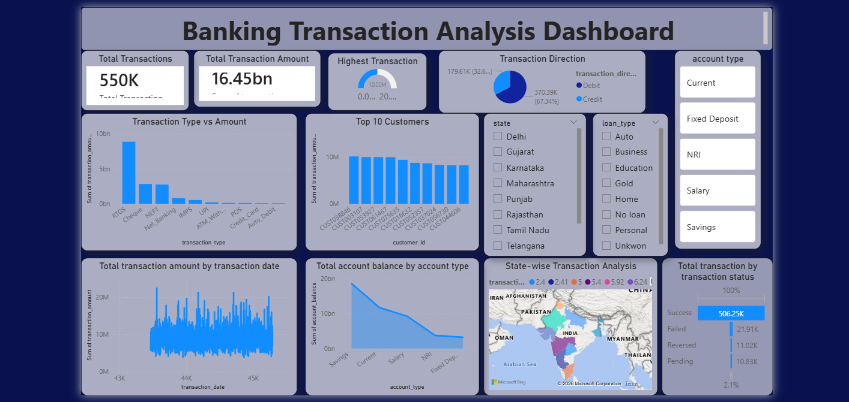
Dashboard Includes
- KPI Cards
- Transaction Type vs Amount
- Monthly Transaction Trend
- Transaction Direction Analysis
- State-wise Transaction Analysis
- Top Customers
- Transaction Status Analysis

Customer Financial Behavior Dashboard
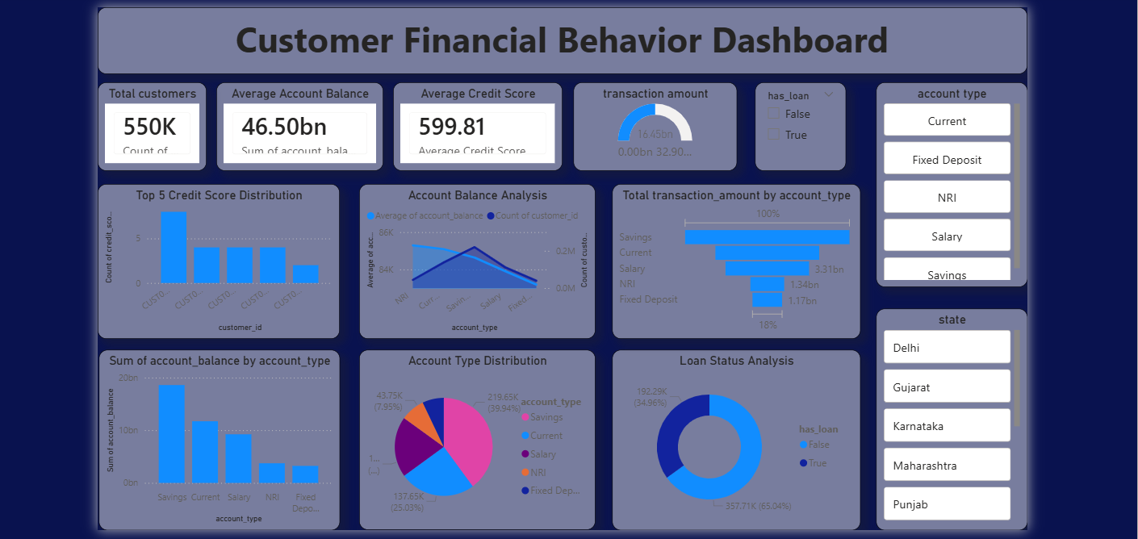
Dashboard Includes
- Customer KPI Cards
- Credit Score Analysis
- Account Balance Analysis
- Loan Status Analysis
- Account Type Distribution
- Transaction Amount by Account Type

Insights
- RTGS transactions contribute the highest transaction amount.
- Debit transactions are higher than credit transactions.
- Savings accounts are the most commonly used account type.
- Most transactions are completed successfully.
- Some customers perform significantly high-value transactions.
- Many customers maintain moderate to good credit scores.
- Certain states contribute more banking activity than others.
- Customers with higher balances usually perform larger transactions.

Conclusion
This project successfully transformed raw banking transaction data into an interactive Power BI reporting solution. By integrating, modelling, and analysing the data, the dashboards provide clear visibility into transaction performance, customer financial behavior, account activity, and banking operations.
The insights generated support data-driven decision-making for customer analysis, transaction monitoring, financial planning, and operational improvement.
This project demonstrates practical skills in:
- Data Cleaning
- Data Preprocessing
- Power Query
- Data Modelling
- DAX Calculations
- Dashboard Design
- Business Intelligence Reporting
making it a strong portfolio project for a Data Analyst / Business Intelligence Analyst role.

